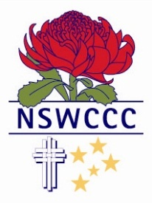

NSW COMBINED CATHOLIC COLLEGES SPORTS ASSOCIATION

OLIVER HOWITT
Blue Award
2015
Baseball
Mater Maria Catholic College Warriewood

Oliver is an outstanding Baseball player who has represented the New South Wales Combined Catholic Colleges team in 2014 and 2015 and also the New South Wales All Schools team that represented New South Wales at the Pacific School Games in 2015.
At the Pacific School Games trials, Oliver’s performance as a starting pitcher for the New South Wales Combined Catholic Colleges team earned him selection to the New South Wales All Schools team.
Oliver was used as a pitcher primarily and then used with the field. His curve ball was unhittable and outstanding velocity for his strikeouts. Making two starts at the Pacific School Games, Oliver through well in his first outing against Western Australia and then started the semi final against South Australia.
His contribution was significant to the New South Wales team and contributed to the team’s performance in winning the Gold medal.
Oliver and is an active participant in sporting and social justice activities at his school.

